# Report of Assignment 4

Group Members:

Kaiyuan Zhao NUID: 001819074

Yuchen Qiao   NUID:001293335

Jianxi Li NUID:001824796

As a software engineers, we used software engineering techniques to develop a application to measure how is the quality of the University education improve a student’s career after they graduated.

We developed an object model as figure 1 shows, The University has different colleges and for each college has different departments, departments has its own course catalog and faculty and staff, for each faculty it has teacher’s information, like which course this teacher is assigned and teacher’s salary. For each staff it has salaries. Staffs are the workers in the university. It separated by part time and full time. Students can enroll any classes they want for each semester. After the semester is done, they can check their course grades through transcript. Also, we have a parent system which can allow parents to check their kids grade if they logged in. Those are inherit from Person class. For each courses, it has informations like credit hours and course name. We have an ArrayList called <CourseOffering> which contain all the course informations like teacher’s information, date of the course offered and classroom information. If a student full filled all the core courses and elective courses, he can get a degree and graduate. After a student graduated he can get a job, in Career class, it has a ArrayList called <CareerHistory>, User can find salaries this student get for each year. Those are the summary of the Object Model in Figure

<https://drive.google.com/file/d/1Hv7iN-6huSKLVJ3G8QMHFEsPhbyUGaZu/view?usp=sharing>

Object Model;

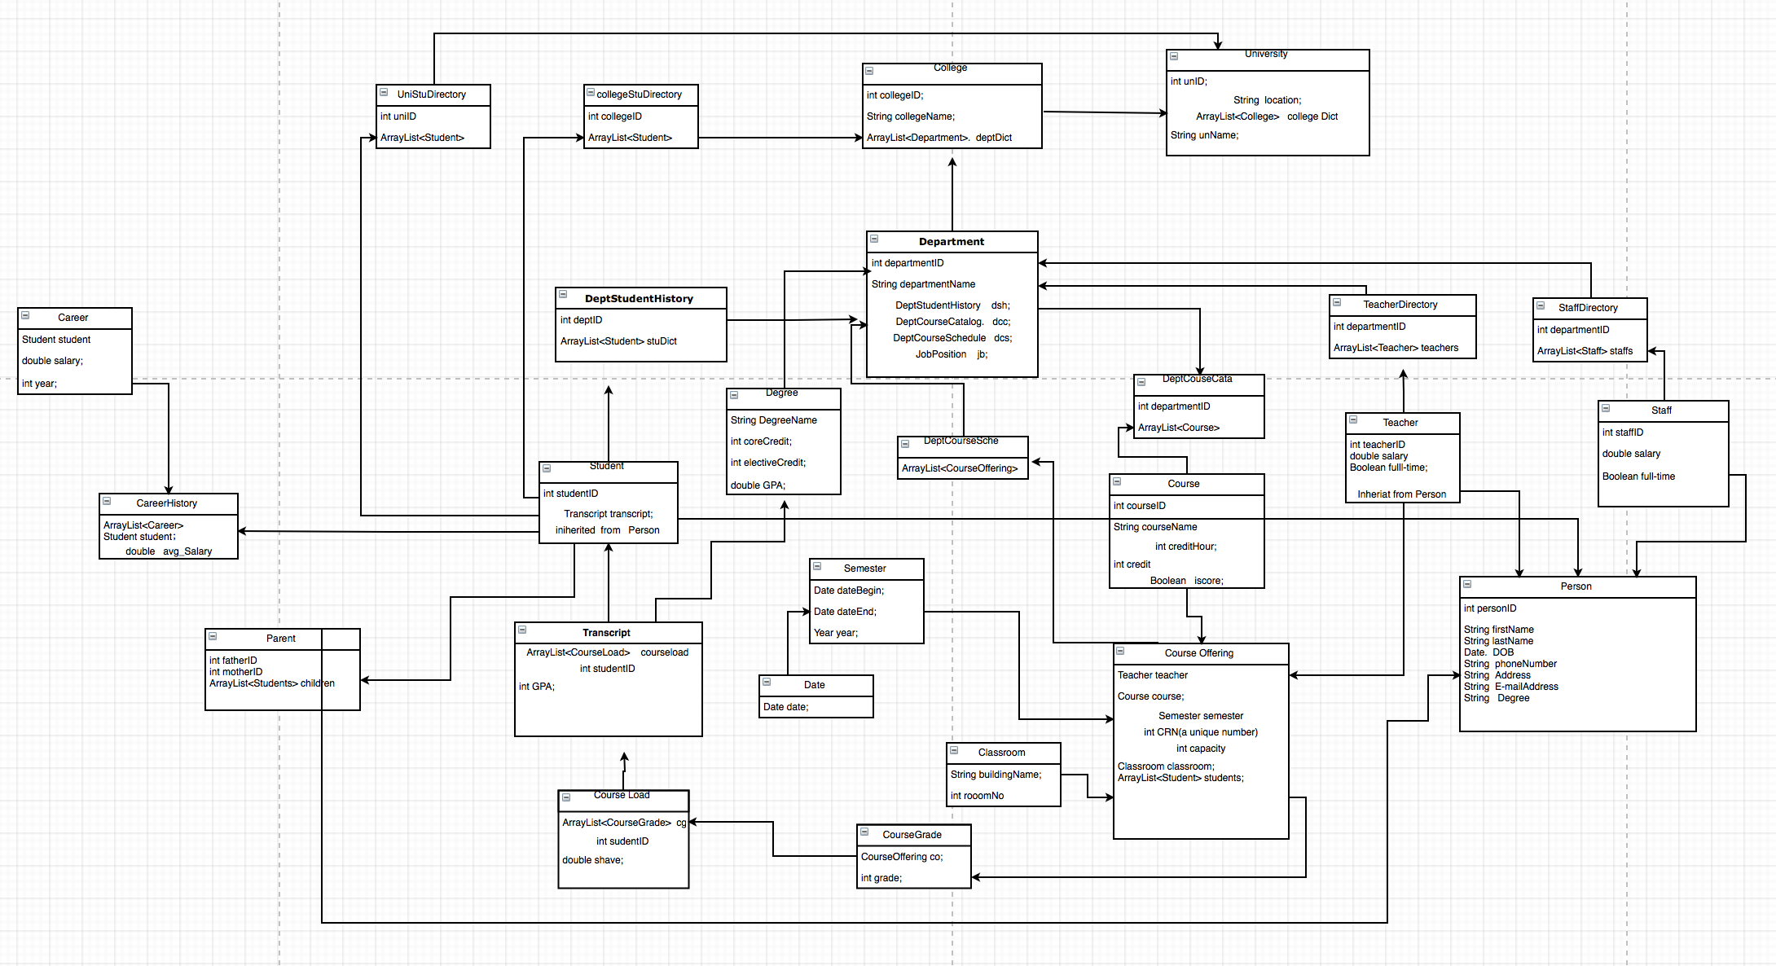

Sequence model:

[Click Here](https://drive.google.com/file/d/1gKAJSK4HKJ7cAB6yjq89AS03mIFtl-P9/view?usp=sharing)

Check which Course have the most attribute of the Students’ growth.

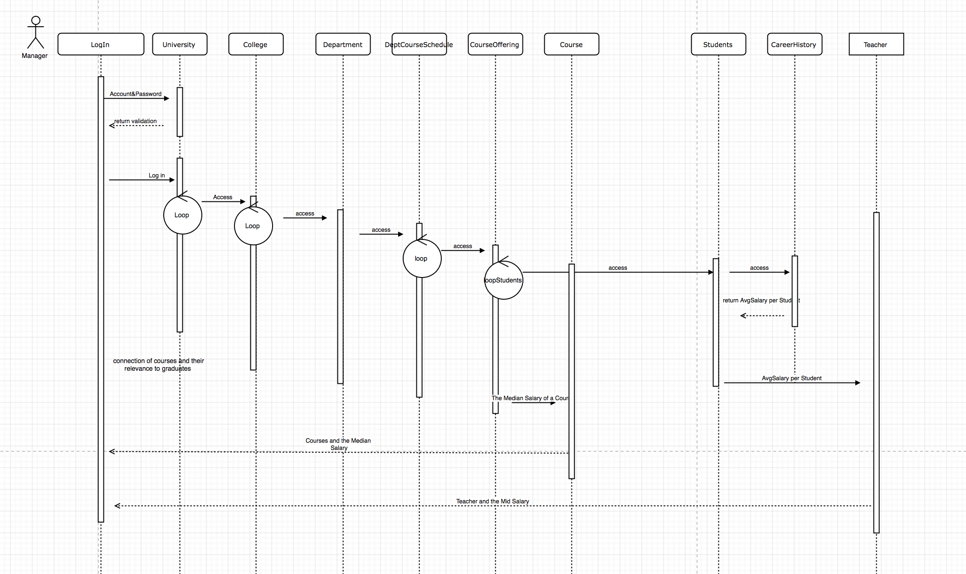

I use the Salary to judge the

Q1: What are the courses we teach?

A1: 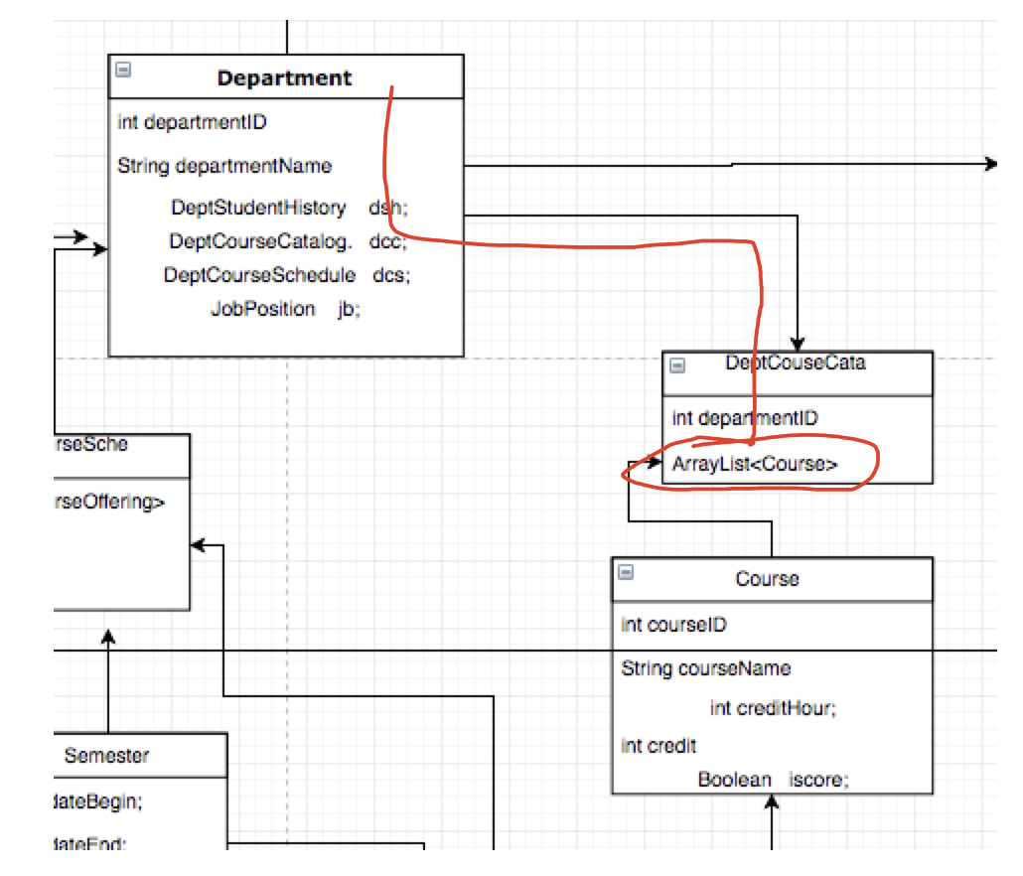

From the department we can access to the DepartmentCourseCatalog, and in this class, there is an ArrayList to store all the course, so we can use a for loop to access all of the course.

Q2: What are the courses we offer at any given semester?

A2: 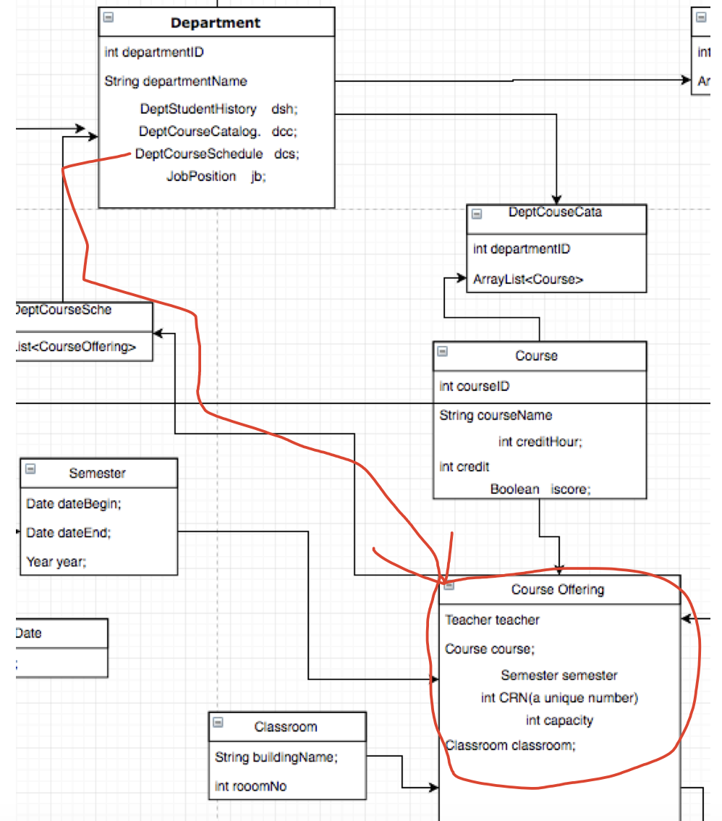

just like the first question, but at this point we need access from the DeptCourseSchedule and use a for loop and if clause to find all the courses’s name and use a hashset to find out the unique CourseID or CourseName.

Q3: Which courses are core and which ones are electives? What are the course requirements?

Q3: Undecided yet. I plan to use a Boolean iscore to distinguish the core course and elective course.

Q4: What are the degree requirements?

A4: if the student get enough coreCredit and electiveCredit , also the GPA is higher than some point such as 3.0, the student can get the degree.

Q5: What is our current capacity? How many seats are empty?

A5: when we initialize a CourseOffering object , we need to initialize the number of the capacity of a course(section), and the seats empty we can use the for loop to find how many students have selected this course and SeatEmpty= Capacity- numberHasBeenSelected;

Q6: What is our faculty/student ratio per class? How do we compare with other departments in the college?

A6: ??? I’am not sure what the class mean. If you mean the specific class section, just count how many student in the ArrayList of this CourseOffering. And ratio = 1/ArrayList<Student>.size();

Q7: What is the average number of students per class? Largest class? Smallest class?

A7: 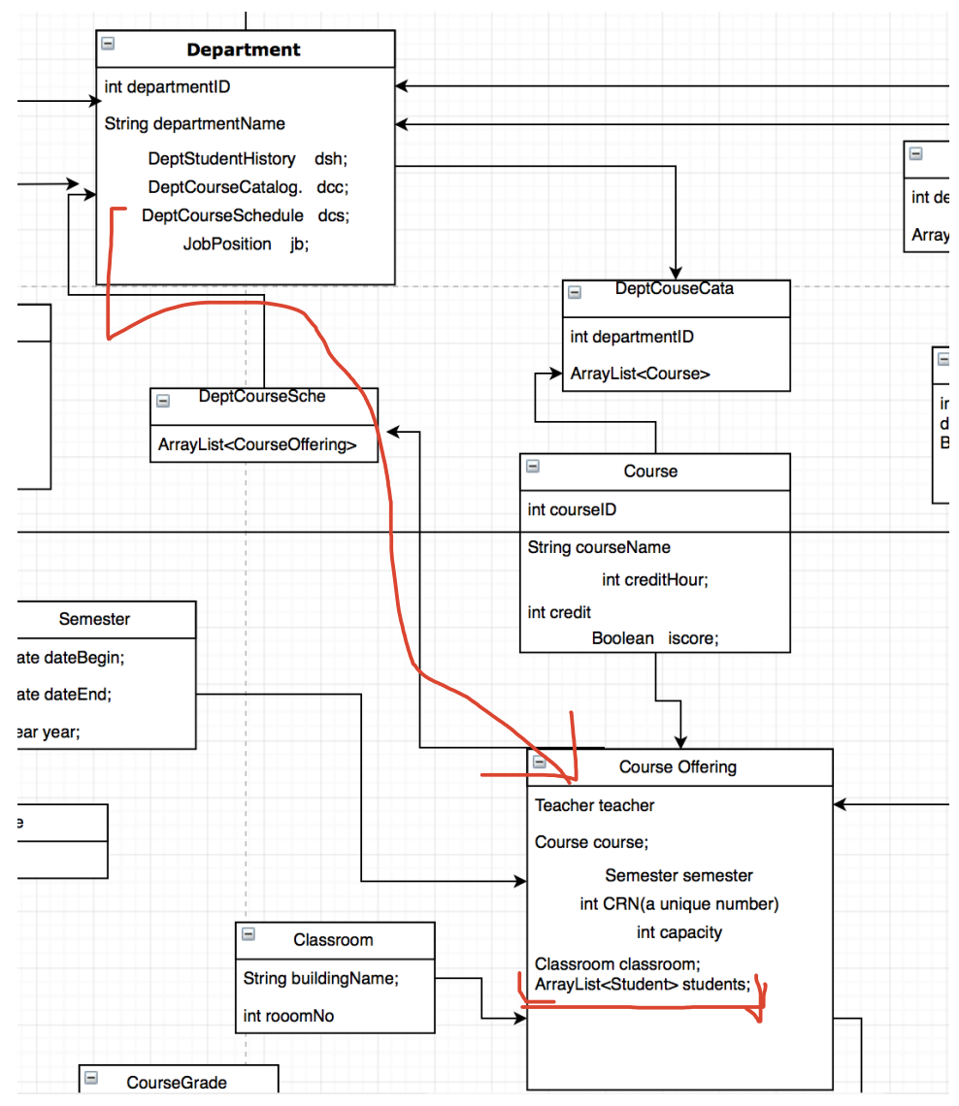

From the department class, to access the CourseOffering class and get the size of the ArrayList of Student. Add the CRN and the number of students in to a new ArrayList. Sort the ArrayList by number of Students, and you can find out the largest and the smallest class.

Calculate the average of the number of students.

Q8: What is the current student enrollment in our department?

A8:Undecided yet.

Q9:What is the administrative staff to faculty ratio?

A9: 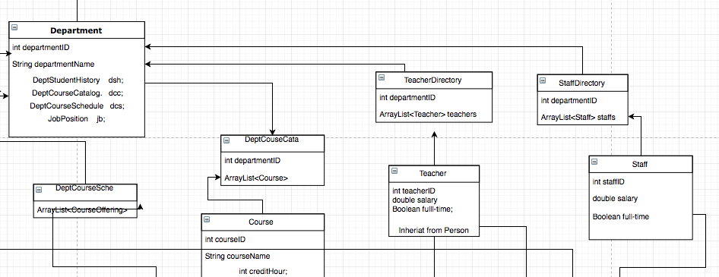

Access to Teacher Directory and Staff Directory, and get the size of the ArrayList

Ratio=staffs.size()/teachers.size();

Q10: What is the ratio of full time faculty vs part-time?

A10: In this case, faculty only include Teachers So, at first we need to use a for loop to traverse the whole ArrayList and use an if clause count the full-time and part-time separately. SO the ratio is count(full-time)/count(part-time)

Q11; What is the percentage of faculty with Ph.D. s?

A11: I have set an attribute of degree, Access to the Teacher class , and use a for loop to access the faculties, and count the number which person.degree.equals(“Ph.D”).

And get the size of the ArrayList.

The percentage= the number which person.degree.equals(“Ph.D”)/ teacehrDirectory.size();